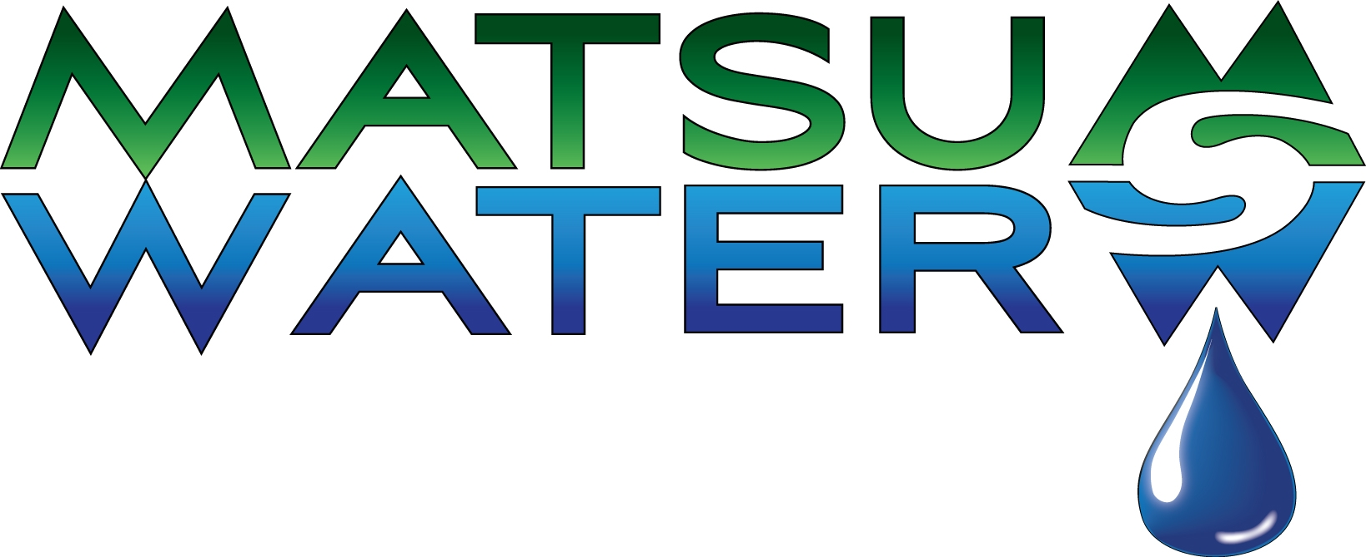

1649 W Parks Hwy, Wasilla
373-2424 * 1-888-291-2444
$5.00 Water Analysis

Name People
Address Any Filters?
Softener? Well (pub. or pvt.)?
Phone Odors?
Tastes?
Date Goal?

pH _________________
6.9-7.5 is normal range. The pH test measures acidity or alkalinity. Low pH may cause corrosion. Above 7.5 indicates excessive alkalinity and may cause unpleasant taste.

Total Hardness _______________ gpg (grains per gallon)
Less than 3 gpg is good. This test measures the amount of the minerals calcium and magnesium in water. Hard water minerals cause scale build-up in pipes and fixtures, fittings, valves, and appliances. Also causes spotting on dishes and glass and causes soap to curd (inhibits lathering and rinsing ability). Mineral build-up causes increased energy costs and shortens the life of any appliance using hot water.

Dirt and Sediment ________________
A visible inspection for dirt and sediment over 40 microns in size. Dirt and sediment will eventually clog working parts of water using appliances.

Total Iron ________________ ppm (parts per million)
Less than .3 ppm is best. This test measures the total amount of all types of iron in water. Over .3 causes brown-red staining on fixtures, dishes, and laundry. It usually darkens coffee, tea, and other beverages.

Total Dissolved Solids _______________ ppm (parts per million)
A test to indicate the amount of solids dissolved in water. 200 is a good starting point. Less TDS will improve taste and more TDS will decrease water palatability.

EMAIL OR TEXT#:_______________________________________________________________

