Date Paid:

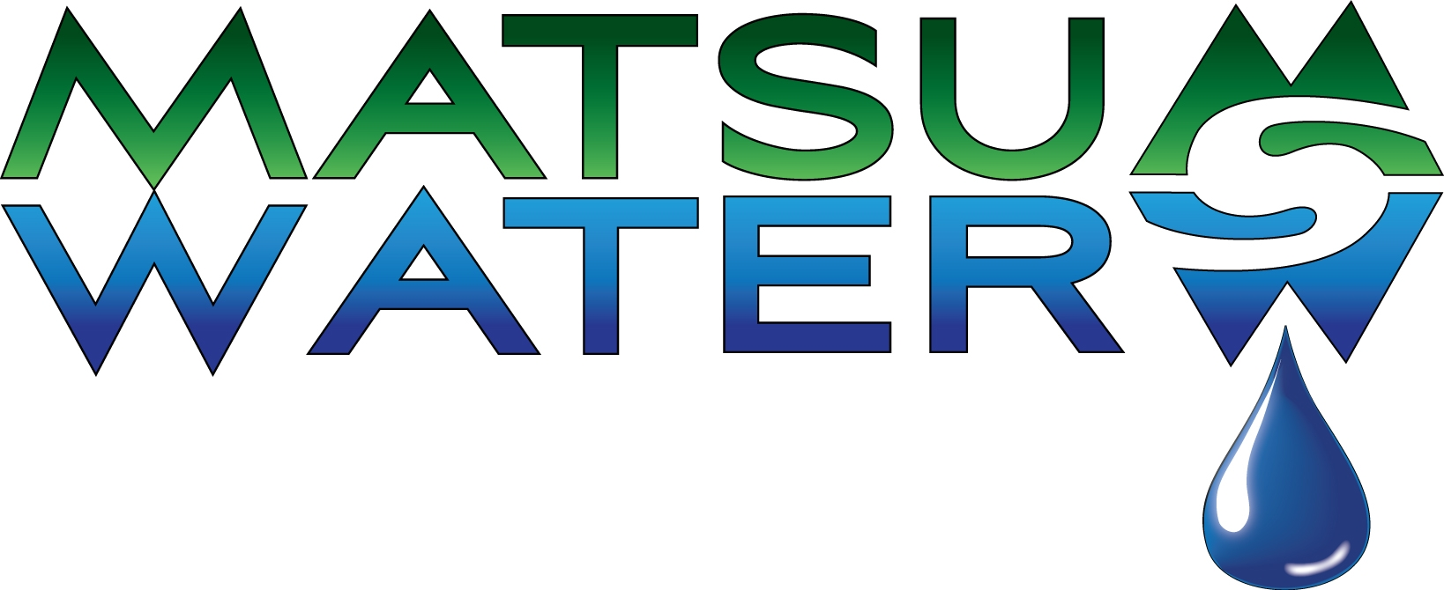

1649 W Parks Hwy, Wasilla
907-373-2424 * 1-888-291-2444

$5.00 Water Analysis

Name Beds/ Baths?
Address Any Filters?
Softener? Well (pub. or pvt.)?
Phone Odors or Taste’s?
E-MAIL:_________________________________________________________________________

Notes:________________________________________________________________
pH _________________
6.9-7.5 is normal range. The pH test measures acidity or alkalinity. Low pH may cause corrosion. Above 7.5 indicates excessive alkalinity and may cause unpleasant taste.

Total Hardness _______________ gpg (grains per gallon)
Less than 3 gpg is good. This test measures the amount of the mineral’s calcium and magnesium in water. Hard water minerals cause spotting on dishes, scale build-up in pipes, water heaters and appliances. Scale build-up causes increased energy costs and shortens the life of hot water appliances.

Dirt and Sediment _______________
A visible inspection for dirt and sediment over 40 microns in size. Dirt and sediment will eventually clog working parts of water using appliances.

Total Iron ________________ ppm (parts per million)
Less than .3 ppm is best. This test measures the total amount of all types of iron in water. Over .3 causes brown, red, orange or yellow staining on fixtures, dishes, and laundry.

Total Dissolved Solids _______________ ppm (parts per million)
A test to indicate the amount of solids dissolved in water. 200 is a good starting point. Less TDS will improve taste and more TDS will decrease water palatability.

DATE TESTED/ INITIAL:____________________________________________________________
Recommendation’s:____________________________________________________________________________________________________________________________________________________________________________________________________________________________________________________________________________________________________________________________

